Week in Review: February 15 - 21, 2002
Alex Shvartsman
Friday, February 22, 2002

Grand Prix-Fukuoka
With about 450 players in attendance, it was a relatively small Grand Prix for Japan. Held on the southern island of Kyushu, a two-hour flight from Tokyo, it could not muster the same kind of numbers as tournaments around Tokyo itself or Osaka might. Still, most of the usual suspects were there.
Top 8 featured some of Japan's best. Itaru Ishida, who had an amazing year having won the largest Grand Prix ever held, navigated his team Panzer Hunters to a second place in the Masters, and won the prestigious Japanese "Finals" tournament held every year on December 31. Tsuyoshi Fujita, finalist of Pro Tour-Tokyo who also participated in the Magic Invitational this year. GP-Yokohama finalist Masahiro Kuroda and GP Kobe finalist Shuhei Nakamura round up what the Japanese Sideboard called "the best GP in Japan".
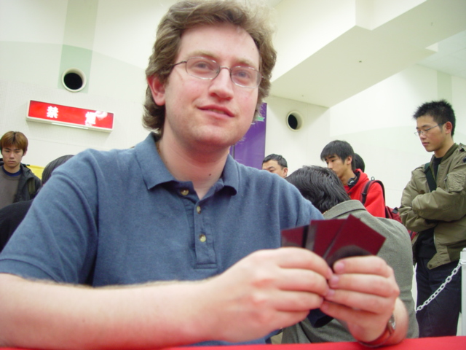
Masahika Morita has three previous GP Top 8s, including a 2nd place finish in Shizuoka - the most recent Japanese GP. He now has two back to back 2nd place finishes, having lost in the finals. To me.
Grand Prix-Fukuoka is the first individual Grand Prix held in Japan to be won by a foreign player. The first GP won by foreigners overall, was also one of my other 2 GP wins (Trevor Blackwell, Nick Wong and I won in Nagoya, and I have another individual win in GP-Tours). ABU won Grand Prix-Yokohama, but this is the first individual event where a foreign player finally won, and I am proud to have been the one to do it.
I now join a small group of triple GP winners. Others are Trey Van Cleave, Chris Benafel, Ryan Fuller, Jim Herold, Steve O'Mahoney Schwartz and Jon Finkel. There are approximately ten players who have two GP wins. Kai Budde has five so, as has become a custom in competitive Magic, it is now a race for the second place behind Kai. This GP win has also allowed me to regain second place in the Player of the Year race, briefly lost to Jens Thoren.

Coming Up: Grand Prix-Tampa

It may be called GP Tampa, but it will really be held at St. Petersburg, FL. It will be the first opportunity for most North American pros to test their skills at playing with Torment. The attendance should be high - who wouldn't want to travel to Florida for a weekend in the middle of winter? More than an average number of New Yorkers are coming down (some are even driving!).
Can ex-Englishman and now resident Floridian Warren Marsh qualify for the PT? Will Gerardo Godinez or any other players from Mexico make the trip up? Will Florida's dealer extraordinaire Jose Cintra buy every card in the room? We will have lots of fun answering these questions next weekend.

Magic in Time Magazine?
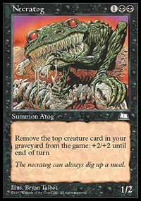
And you thought he was only good in Block.
Well, not quite. However, when reading this week's issue of Time I happened upon a feature article about the online sharing of music, TV shows, movies, etc. One of the people mentioned is a webmaster who wanted to be referred to by alias only - Necratog! I can't think of any way a non-Magic player would arrive at that name, and found it hilarious that an Atog sneaked into Time magazine.

Magic Trivia
Last week's question:
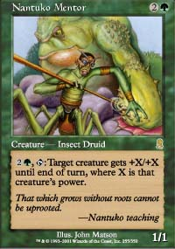
You are playing a game of OD-OD-TO draft. You have two 1/1 creatures in play. Although you cast no spells at all this turn or next turn, you are able to attack for sixteen points of damage on your next turn. How is that possible?
At the end of your turn, discard your eighth card, or sacrifice Timberland Ruins or put a card into your graveyard in any other way to reach threshold. Your two creatures are Nantuko Mentor and Krosan Beast. The Beast becomes 8/8. Activate Mentor to make it 16/16 and charge!
New Question:
Courtesy of Jake Abdalla
You have no cards in your hand and no cards in your graveyard. You have any number of cards left in your deck. You have 11 islands and 11 mountains in play. You are at 1 life. Your opponent is at 20 life, and has just cast Urza's Rage targeting you. With the Rage on the stack, your opponent has no cards in hand or graveyard, and 8 islands untapped. You have one nonland permanent in play. What permanent could you have in play that would allow you to win the game in this situation?
Please do not email answers to me. The correct answer will be posted in the next column.

Quote of the Week
"I would write an article entitled "Searching for Alex Shvartsman"... But I don't think I could find him, since he travels so much." - John F. Rizzo on Star City.

Play of the Week
Courtesy of Matteo Boca:
"Boring late game in a sealed deck tournament.
I (r-g-u) was at 5 life and my opponent (g-b) was in a bad situation at 9 life (I could win by attacking with everything next turn). In my end-step he drew 5 cards with Skeletal Scrying, going down to 4. He smiled, and said: "I'm too strong!". Then he untapped and cast Overrun, attacking with all of his creatures.
This would be a huge problem if not for a Filthy Cur being a part of his attack force. I sacrificed Barbarian Lunatic to deal two damage to it and then blocked it with Halberdier. First strike damage resolved first, killing my opponent before tons of trample damage could kill me, and the Filthy Cur went flying toward a wall as my mad opponent walked away from the table."

Bad Play of the Week
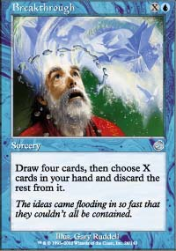
A great way to reach threshold?
Courtesy of Francesco Fore:
"Here's a really awful play from the Torment Prerelease: a guy with a w-g-u deck decided to get threshold on his first turn by laying an island and playing... Breakthrough for 0! Obviously he hadn't really understood the card, but his play already became legendary here in Italy. Needless to say he proceeded to lose this game (as he is quite used to...)."

Bad Play #2
Courtesy of Ryan Ross
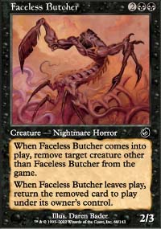
"My friend and I were playing an all-Torment draft. He had Pyromania out with enough mana to activate it three times. I cast Faceless Butcher, targeting his 4/4 Possessed Aven. In response to the Butcher's ability, he activated Pyromania three times targeting it. He did not realize that the Butcher's "remove from the game" ability was last on the stack, so he lost his Aven for good. This cost my friend the match, and the tournament."
Got an interesting news story, comment, quote, play of the week, or Magic trivia to report? Please email me at ashv80@hotmail.com.

